Normal Forms Worksheet

This worksheet is aimed at reinforcing your understanding of the different normal forms and how to move between them. You will be presented with different relations and asked to identify their normal forms and suggest a change that would either elevate the relation to the next highest form or lower it. The diagrams were made at dbdiagram.io, a website you might find useful for drafting databases.

1. You are given the following relation:  
   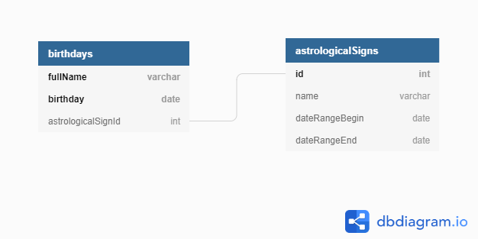  
     
   1. What normal form is the relation in?  
        
      First
   2. How could this form be changed so that it does not violate the next highest form?

Delete astrological id and make the astrological table based off birthday ranges

1. You are given the following relation:  
   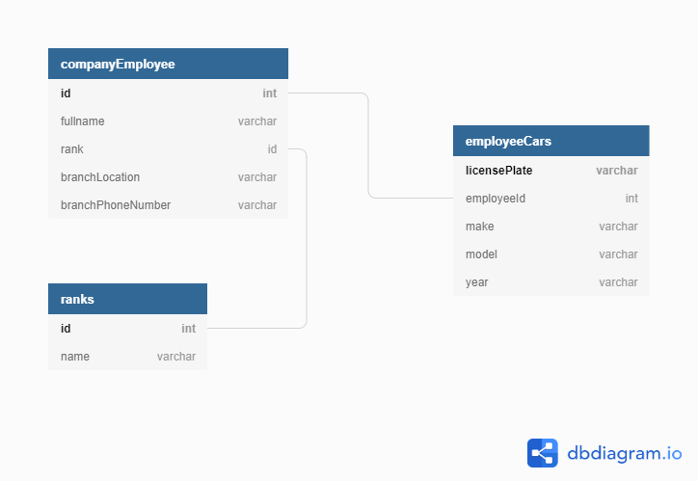  
     
   1. What normal form is the relation in?  
        
        
      Second
   2. How could this form be changed so that it does not violate the next highest form?

Create a branch table pointed to by branch_id.

1. You are given the following relation:  
   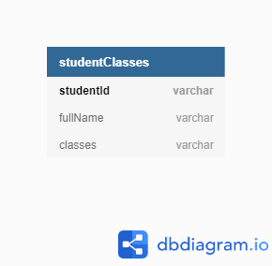  
     
   In addition, one of the rows has the following data: (12345, Jacob Davis, [ENG101, MATH200, SCI231]). That is, *classes* is a multi-value column.  
     
   1. What normal form is the relation in?

None

* 1. How could this form be changed so that it does not violate the next highest form?

Create a new table of class relations with student_id and class_id. Then create another table of classes with class_id and class_desription

1. You are given the following relation:  
   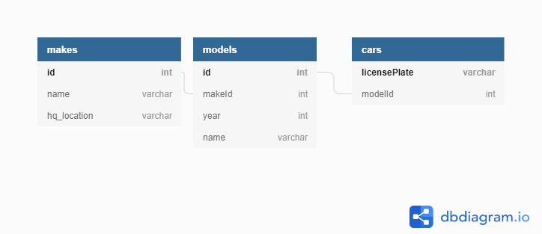  
     
   1. What normal form is the relation in?  
        
      Third
   2. How could this form be changed so that it only meets the next **lowest** form’s requirements? In other words, how would you reduce the normalization of this relation?

Include make and hq_location in the models table to create a transitive property